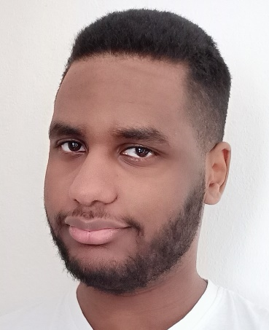 |  |  |  |  | Jamal Alniel  - Hoorn | 28/04/2001 | JamalAlniel2804@gmail.com | Game developer  A game developer and student at Mediacollege Amsterdam learning to code and how to make games. Specializing in gameplay and making a game fun to play, also interested in learning VR game development.

Experience

Mediamarkt IT assistant Internship
At this internship I was working at the smartbar where costumers could come up and ask questions or request repairs. I have done a wide variety of troubleshooting work from repairing broken laptops and phones to fixing software problems and helping setup certain devices

FBCS Spanbroek IT assistant internship
My work here consisted mainly of maintenance and cleanup of user devices doing both hardware and software maintenance, I also did repairs when needed and learned to work with a lot of devices.

Education

IT Assistant Level 2-3
ROC Kop van Noord-holland, Schagen – Medewerker ICT MBO-2.
Horizon college, Hoorn – Allround medewerker IT system and devices MBO-3.
I learned to operate, maintain and troubleshoot different computer systems both hardware and software, I also learned much about customer support and how to solve and catalogue support tickets

Mediacollege amsterdam – Game development
Learning everything about game development and how to make games. I have learned to write code and made several project using unity and unreal and have learned how to work in a team of developers and artist using different teamworking technique’s to accomplish our goals.
Skills |  |  |  |  |  |  | Hobbies
- Experience with unity engine  - C# Experience  - Experience with unreal engine  - Blueprint coding  - Background in IT  - Fluent in English and Dutch  - Experience in Blender |  |  |  |  |  |  | My hobbies include playing, researching and competing in my favorite games, learning about the video game industry and overall just trying new things and seeing if I like it.  My favorite games include: Guilty gear Strive, Blazblue, Limbus company, Library of ruina and more.

